***PAAREES PERFUMES***

***Christian Diors***

***FOR UNISEX***

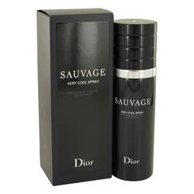

# *Sauvage Very Cool*

***Description:***

Sauvage Very Cool by Christian Dior Cologne. Created by master perfumer Francois Demachy and launched in 2017, Sauvage Very Cool is a fresh and intriguing cologne for men that is ideal for everyday wear and an excellent start to any morning routine. From the aromatic fougere group of fragrances, this warm and spicy blend is sure to leave your mark. Top notes for the cologne consist of sweet and sour grapefruit, Reggio bergamot, and softly spicy pink pepper. Hot Sichuan pepper, earthy vetiver, sensual Provencal lavender, and fragrant geranium make up the tantalizing middle notes of the blend. The base notes finish off with rich patchouli, cedar, elemi resin, and ambroxan accords.  
  
The French fashion company of Christian Dior was founded by the world-renowned designer of the same name, and produces clothing, accessories, and fragrances for both men and women. The company started producing perfumes and colognes as early as 1947 and has contributed to over 200 fragrances sold at many department stores worldwide and online.